**AWS EFS**

AWS EFS (Elastic File System) is a fully managed cloud-based file storage service offered by Amazon Web Services (AWS). It provides scalable and shared storage that can be accessed concurrently by multiple Amazon EC2 instances across different availability zones within an AWS region.

**Key features:**

**1. Scalability:** AWS EFS can automatically scale its capacity up or down based on demand, without requiring manual intervention. This makes it suitable for a wide range of workloads, from small to large-scale applications.

**2. Shared File System:** Multiple EC2 instances can access the same file system simultaneously, making it ideal for applications that require shared access to data, such as web hosting, content management systems, and development environments.

**3. Fully Managed:** AWS EFS is a managed service, which means that AWS takes care of routine tasks such as hardware provisioning, software updates, and backups, allowing users to focus on their applications rather than managing the underlying infrastructure.

**4. Security:** AWS EFS supports multiple layers of security, including AWS Identity and Access Management (IAM) for access control and encryption of data at rest and in transit.

**5. Performance Modes:** AWS EFS offers two performance modes: General Purpose and Max I/O. General Purpose mode is suitable for most workloads, while Max I/O mode is designed for applications with a high number of concurrent connections and requires more throughput.

**Storage Classes:**

With Amazon EFS, you can choose from a range of storage classes that are designed for different use cases:

1. EFS Standard – A regional storage class for frequently accessed data. It offers the highest levels of availability and durability by storing file system data redundantly across multiple availability zones in an AWS region.
2. EFS Standard-Infrequent Access (Standard-IA) – A regional storage class for infrequently accessed data. It offers the highest levels of availability and durability by storing file system data redundantly across multiple availability zones.
3. EFS One Zone – For frequently accessed files stored redundantly within a single availability zone
4. EFS One Zone-IA – A lower-cost storage class for infrequently accessed files stored redundantly within a single availability zone.

The EFS Standard storage classes are regional storage classes that store file system data and metadata redundantly across multiple geographically separated availability zones with a region. They offer the highest levels of availability and durability, providing continuous availability to data even when on or more availability zones in a region are unavailable.

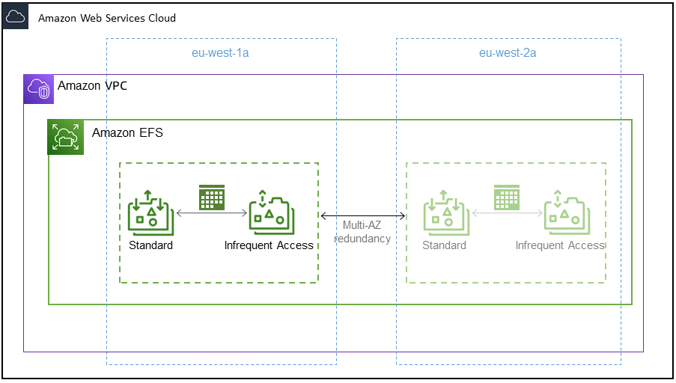

The EFS One Zone storage classes are lower cost, single availability zone storage classes. They store file system data and metadata redundantly in a single availability zone within a region. Both of the IA storage classes reduce storage costs for files that aren’t accessed every day. If you need your full dataset to be readily accessible, and you want to automatically save on storage costs for files that are less frequently accessed use IA storage

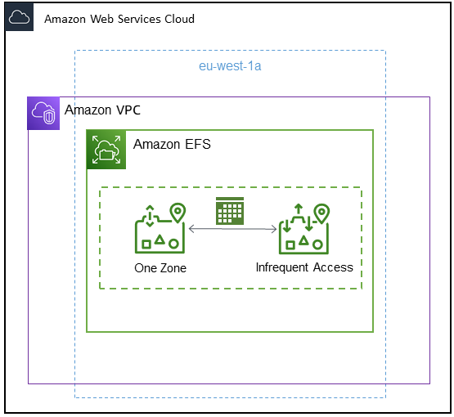

**EFS Lifecycle Management:**

Amazon EFS lifecycle Management automatically manages affordable file storage for your file system. When enabled, lifecycle management migrates files that have not been accessed for a period of time to an infrequently accessed storage class, Standard-IA or One Zone-IA.

**To Create EFS file system:**

1. Sign in AWS Management console.
2. Choose Create file system to open the create file system dialog box.


            Create file system diaolog box showing the optional file system name and default
              VPC, with the Customize and Create
              buttons.
          

1. Enter Name(optional)
2. For Virtual Private Cloud (VPC), choose your VPC, or keep it set to your default VPC. Click on Customize.

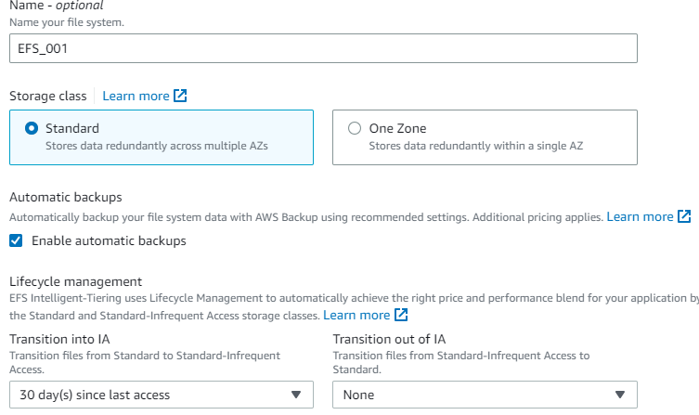

1. Storage class-choose standard.
2. Lifecycle Management- Amazon EFS Creates files systems with following file policies.

Transition into IA set to 30 days since last access.

Transition out of IA set to none.

1. Throughput mode to bursting and Performance mode to General purpose. Click on Next.

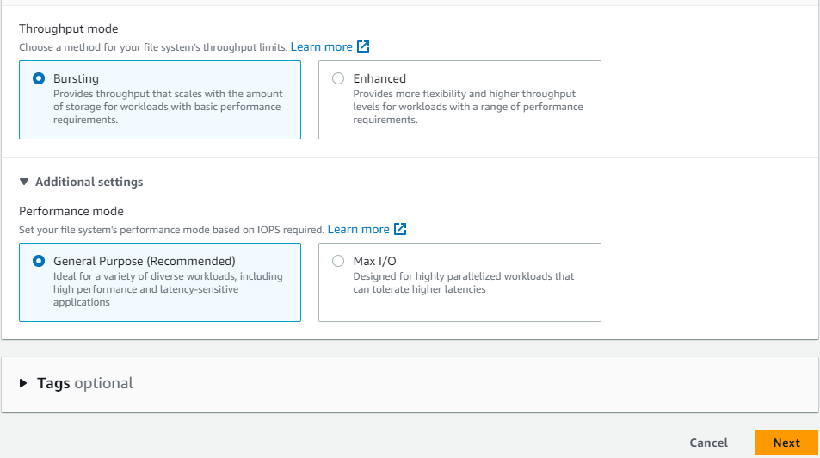

1. After you create the file system, you can customize the file system's settings with the exception of availability and durability, encryption, and performance mode.

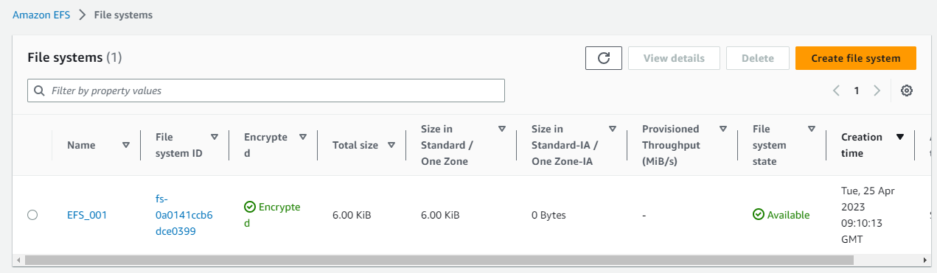

1. Click on EFS_001(Name of File system). The **File systems** page appears with a banner across the top showing the status of the file system you created. A link to access the file system details page appears in the banner when the file system becomes available.

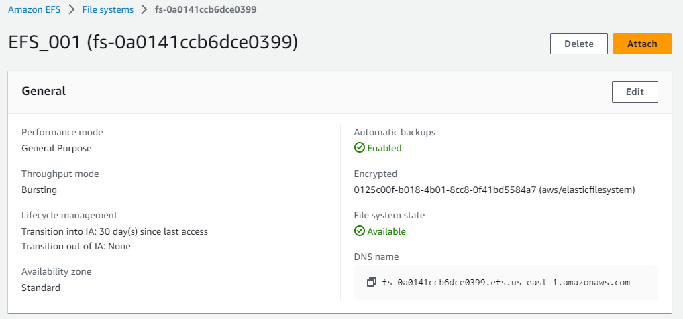

1. Launch two instance by Selecting AMI, configuring VPC, security groups, and Key pair etc.
2. Connect to instance by EC2 instance connect.
3. Click on Attach on EFS file system page.

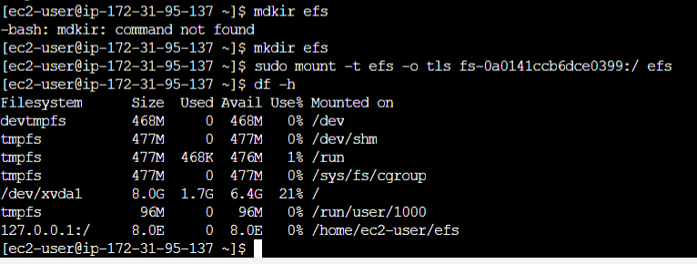

1. Below Option appear on screen.
2. In both instances, first create a directory called efs in root directory and run the command to mount.
3. Check, whether it is mounted or not.(df –h)

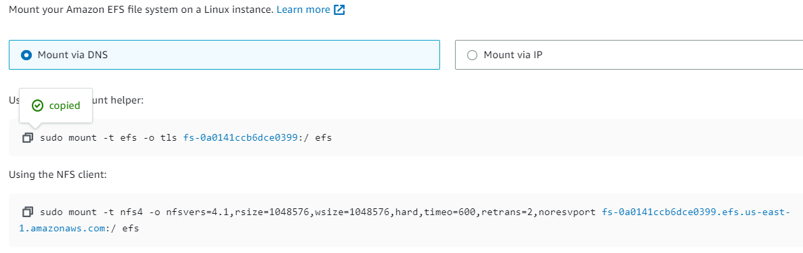

1. Give permission to directory and add content in a sample file.

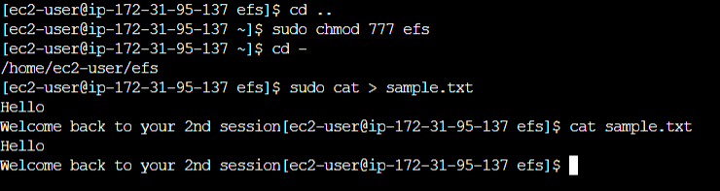

1. Open other instance and check the same directory.
2. Same file with same content has been shared in other server.

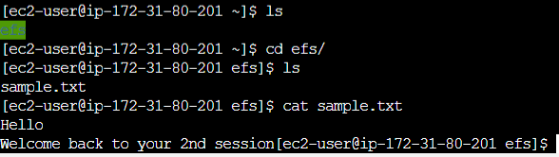

**FAQ’s on EFS:**

1. **What is Amazon EFS?**

A) Amazon Elastic File System (EFS) is a scalable, fully managed, cloud-based file storage service provided by Amazon Web Services (AWS). It offers simple, scalable, and highly available file storage for use with AWS cloud services and on-premises resources.

1. **What are the key features of Amazon EFS?**

* Scalability: EFS automatically scales storage capacity and throughput as your file system grows.
* Elasticity: It can handle thousands of concurrent client connections and supports high levels of throughput and IOPS.
* Durability and Availability: EFS stores file data redundantly across multiple Availability Zones (AZs) to ensure high durability and availability.
* Shared File System: EFS allows multiple instances to access the same file system simultaneously, making it suitable for use cases like content management, web serving, and data sharing.
* Integration with AWS Services: EFS integrates well with other AWS services like EC2, ECS, Lambda, and EKS.

1. **How is data stored in Amazon EFS?**

A) Amazon EFS stores data in a distributed manner across multiple Availability Zones within a region. It uses the Network File System (NFS) v4 protocol, providing POSIX-compliant file system access semantics.

1. **How does Amazon EFS handle scalability?**

A) Amazon EFS automatically scales storage capacity and throughput in response to the amount of data stored and the level of file system activity. This allows you to accommodate growing workloads without manual intervention.

1. **Is data stored in Amazon EFS durable and highly available?**

A) Yes, Amazon EFS is designed to be highly durable and available. It stores data across multiple Availability Zones, ensuring that data is replicated and protected against infrastructure failures. It also provides built-in data redundancy and automatic failover capabilities.

1. **Can I share files across multiple instances with Amazon EFS?**

A) Yes, Amazon EFS allows you to share files across multiple instances concurrently. This makes it suitable for applications that require shared file access, such as content management systems, development environments, and containerized applications.

1. **What are the use cases for Amazon EFS?**

A) Amazon EFS is commonly used for a variety of use cases, including:

* Web serving and content management systems
* Big data analytics
* Media processing workflows
* Container storage
* Development environments
* Home directories

1. **How do I access Amazon EFS from my instances?**

A) You can mount an Amazon EFS file system on your instances using the NFSv4 protocol. You need to install the NFS client on your instances and configure the mount target information provided by Amazon EFS.

1. **How is Amazon EFS priced?**

A) Amazon EFS pricing is based on the amount of data stored in the file system and the level of file system throughput. There are separate charges for storage capacity and data transfer. You can refer to the AWS Pricing page for detailed information.

1. **Is there a limit to the size of the file systems in Amazon EFS?**
2. Amazon EFS supports file systems of virtually unlimited size. The maximum storage capacity and performance of your file system are automatically scaled based on your usage patterns and requirements.
3. **What security features does Amazon EFS offer?**
4. Amazon EFS supports multiple security features, including:

Encryption at rest: Data can be encrypted using AWS Key Management Service keys to ensure data security.

Network isolation: EFS file systems are isolated within an Amazon VPC and can be accessed only by instances within that VPC.

IAM access control: Access to EFS can be controlled and managed using AWS Identity and Access Management policies

**TASK: Mounting EFS on EC2**

Before mounting, you need to install the NFS client. If you expand the list and click on Amazon EC2 mount instructions, you will get the details.

# Login to EC2 instance and install the NFS client

$ sudo yum install -y amazon-efs-utils

# Let’s create a folder where you want to mount the EFS.

$ sudo mkdir efsdir

# Mount EFS Filesystem (Make sure you changed FileSystem ID)

$ sudo mount -t efs -o tls fs-0a37cdf9d7d2d8f82:/ efsdir

**Note: Make EC2 VM security Group inbound rule having "NFS" protocol with 2049 port number**

# Change the directory to the mount point that is created above using the command:

$ cd efsdir

# Create a new sub directory with following command:

$ sudo mkdir begin

# Change the permissions of the above subdirectory with the following command:

$ sudo chown ec2-user begin

# Change the directory to begin directory with following command:

$ cd begin

# Create a sample text file:

$ touch myfile.txt

# Run ls command to list the contents of directory.

**Note: Create another ec2 instance and mount EFS file system**

# Login to EC2 instance and install the NFS client

$ sudo yum install -y amazon-efs-utils

# Let’s create a folder where you want to mount the EFS.

$ sudo mkdir efsdir

# Mount EFS Filesystem (Make sure you changed FileSystem ID)

$ sudo mount -t efs -o tls fs-00fc4e2c6aee19e2e:/ efsdir

# Change the directory to the mount point that is created above using the command:

$ cd efsdir

# check the files available

$ ls

**Note : The files we have created in First EC2 instance, should display in second ec2 instance.**

AWS EFS, EBS, and S3 are three different storage services provided by Amazon Web Services, each designed for specific use cases.

**1. Amazon EFS (Elastic File System):**

- Use Case: EFS is designed for use cases that require shared file storage accessible by multiple EC2 instances. It is suitable for applications that need a scalable and shared file system, such as content management systems, web hosting, and development environments.

- Performance: EFS can scale its performance automatically based on the storage size and the number of concurrent clients. It provides good performance for a wide range of workloads.

- Durability: EFS automatically replicates data across multiple Availability Zones, providing high durability and availability.

- Cost: EFS can be more expensive than other options for certain workloads, especially if you have a small number of EC2 instances and low data transfer.

**2. Amazon EBS (Elastic Block Store):**

- Use Case: EBS is used for block-level storage attached to individual EC2 instances. It is suitable for applications that require low-latency and high-performance storage, such as databases.

- Performance: EBS provides consistent and low-latency performance, making it suitable for I/O-intensive workloads.

- Durability: EBS volumes are replicated within an Availability Zone but not across zones. To achieve data redundancy, you can use features like EBS snapshots to back up your data.

- Cost: EBS is typically less expensive than EFS for certain workloads. You pay for the provisioned storage and I/O operations.

**3. Amazon S3 (Simple Storage Service):**

- Use Case: S3 is an object storage service designed for storing and retrieving any amount of data. It is ideal for storing files, backups, static assets, and serving content for web applications.

- Performance: S3 is highly scalable and can handle massive amounts of data. However, it may not be suitable for applications requiring low-latency access due to its eventual consistency model.

- Durability: S3 provides high durability by automatically replicating data across multiple data centers.

- Cost: S3 offers a cost-effective pay-as-you-go model, making it ideal for long-term storage and data archival. It also provides different storage classes with varying costs based on access frequency and retrieval time.

**In summary:**

- Use EFS when you need shared file storage accessible by multiple EC2 instances.

- Use EBS when you need block-level storage directly attached to an EC2 instance with low-latency access.

- Use S3 when you need object storage for storing and retrieving large amounts of data, such as backups, static assets, and web content.